Aspiration Assisted Motor-Driven Biopsy Needle

Report: 11-21-2024

1. **Work Planned to be Completed:**

This week I narrowed my work to 3 things: (1) investigation of current data noise and how it could be reduced, (2) migrating the circuit to use the RP2040, and (3) looking into more formal methods of documentation.

1. The readouts that we get from the current sensor are extremely noisy, making analysis difficult and reducing our ability to distinguish statistical trends. It would be ideal if I could find some way to potentially reduce this through hardware/software filtering or alternative solutions.
2. Getting the new circuit ready will be crucial as we get closer to the beginning of PCB design. Given that we are still utilizing Arduino IDE as the development environment and many libraries should be compatible with the RP2040, this shouldn’t be too difficult. I expect this will mostly just be pin reassignment and maybe iron out 1 or 2 intricacies.
3. Documentation becomes increasingly important as we begin to finalize the design. There should be some formal collection of information regarding how the code operates, the relevant dependencies, and general descriptions. The expectation is that anyone could read it and find themselves with a level of understanding adequate enough to continue development.
4. **Work Completed:**

I have begun adapting the circuit to use the RP2040. There is not much difference code-wise aside from fitting in the previous MSC and SD card content. However, there are differences in pin assignments, as expected. In particular, the Wire instance will need to have the I2C pins manually set. Additionally, because the Feather development board that our RP2040 is packaged on doesn’t come with pull-up resistors built in for I2C pins, we will have to add those manually. I have already selected some 4.7kOhm ones that should be suitable.

As I was assigning the other pins, I realized how troublesome the LCD was. This component requires 2 general pins, power connections, and at least 4 data pins which, although not difficult, are still quite laborious to set up for mediocre results: i.e. limited display space, and a potentiometer or voltage divider for the contrast. This leads me to a proposal for an alternative screen. OLEDs provide good options due to their high visibility and they are very common for environments that demand high power efficiency:

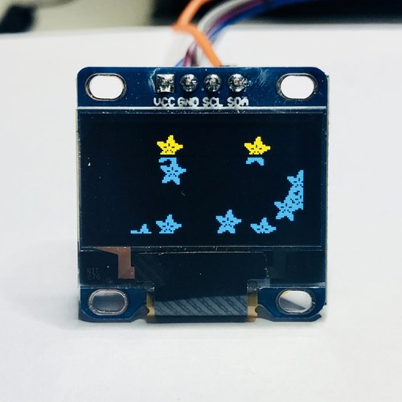

***Figure 1:*** *A smaller OLED that features a substantially higher resolution than our current LCD. Additionally, notice the I2C communication relying only on 2 pins.*

Other alternatives that wouldn’t be so substitutive as much as just pure upgrades would be TFT screens, some of which offer touchscreen capabilities. These are just several options dependent on how we see this product moving forward. Aside from this, the rest of the configurations should be completed, and we can fully test it after breadboarding:

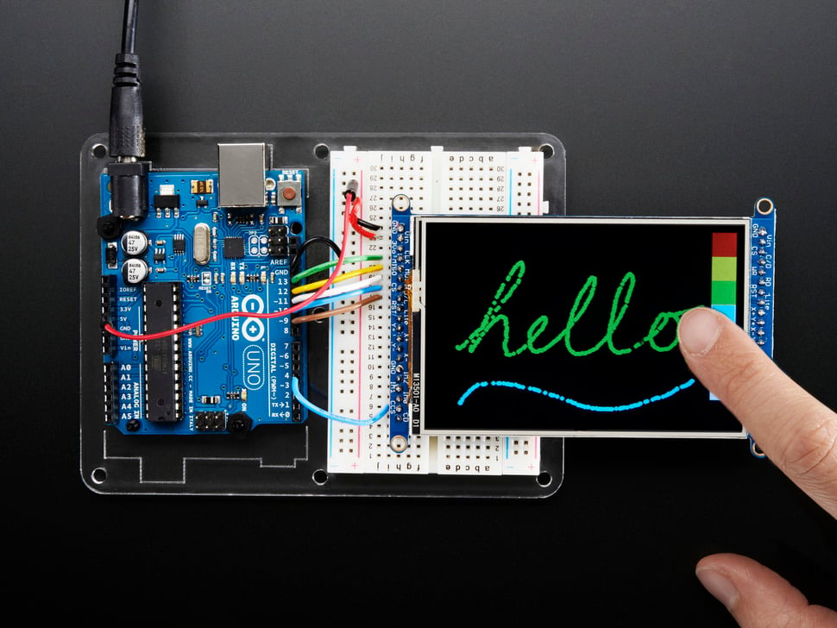

***Figure 2:*** *A touchscreen TFT. Perhaps a bit ambitious but it could be a valuable alternative given how we want to continue the design.*

***Figure 3:*** *TFT display without touchscreen capabilities but has the ability to display images from connected FAT32 formatted SD cards.*

Documentation has been something on my mind ever since I started working on the code for the biopsy needle however we never had a real plan for how to accomplish it. I originally wanted to have a separate PDF document which would have the descriptions and general information regarding how the code operated. However, this would be a tremendous difficulty to upkeep, and I believe version control would be difficult. So far, I have only used in line comments to explain how things work or take note of important qualities, but this hasn’t been ideal. So, I have done a little research into easy to use and implement alternatives. Currently, I have my eyes set on integrating Doxygen, which is a tool that could automatically generate documentation from inline comments.

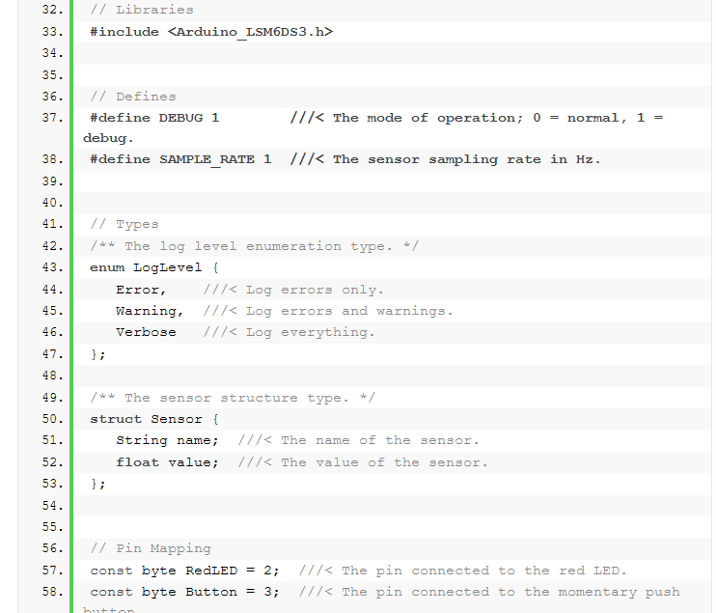

***Figure 4:*** *Sample Doxygen usage with current setup. As shown, in line documentation can be transformed into formal researchable formats (i.e. HTML website-likes)*

That, at the very least, should cover the software documentation. There might be something additional for the circuit diagrams but that’s still in the air. I feel the KiCad schematics we will have should suffice.

Finally, I did some research into the interference seen by the current sensor and potentail solutions or changes we could make to reduce the noise. As previously suspected, the brushed design of the motor is likely the greatest contributing factor to the noise that we observe. The contacts between the brushes and the commutator are generating voltage spikes. Additionally there is also the potential for electromagnetic interference contributing to noise. Several solutions I would like to investigate are:

* **Low-pass filtering:** either with a simple RC circuit or utilizing an op-amp
* **Different current sensor**
* **Software-filtering/averaging:** Kalman filtering, moving average, or other real-time options
* **Decoupling capacitors**

1. **Future Work:**

Next up for things to do is finish the breadboarding of the circuit and begin the documentation. Once I get more information regarding expected currents, I can also wrap up selection for all the power components. If we end up using a different screen display, getting that functional will also be of high priority as well as experimentally reducing current noise.

**Current CEN3907C Due Dates**

|  |  |
| --- | --- |
| *Assignment* | *Due Date* |
| Pre-Alpha Build | 10/25 |
| Driver Lab | 11/1 |
| Elected Lab | 11/15 |
| Design Plan Revision | 11/1 |
| Prototype Presentation | 12/3 |
| Design Prototype | 12/4 |
| Presentation Reviews | 12/3 |